Good Plot:
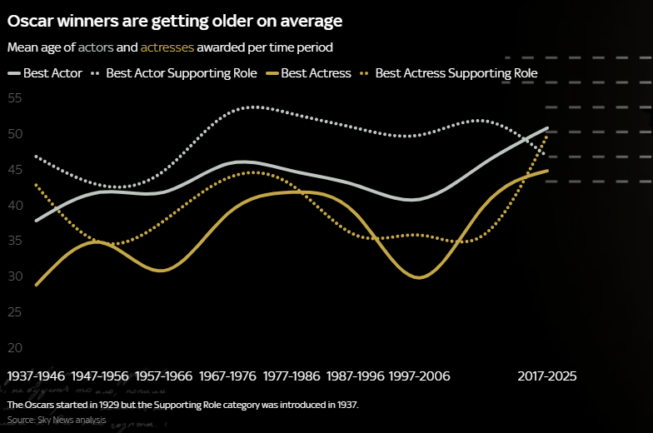

This plot describes the change in age for an Oscar winner over the history of the award. The graphic includes a title which describes the trend displayed, a subtitle specifying what is being plotted, a clear legend, date ranges and footnotes describing how the date range was selected and the source. What to me makes this graph stand out, is the colour scheme which matches that of the award show and how it clearly distinguishes between actors and actresses as well as their supporting role counterpart. The simplicity clearly highlights the gender divide and shows the age increase over time.
What could be improved however, the colour of the y value, which blends with background, especially when the graph isn’t the full size of the screen. Also the gap from 2006 -2017 has not been annotated. To improve, the y axis should be the same colour as the x and all the date ranges to present should be included.
Overall, the graph clearly communicates the information which could be interpreted by any audience which is important when displaying data on a news site.

Bad Plot:
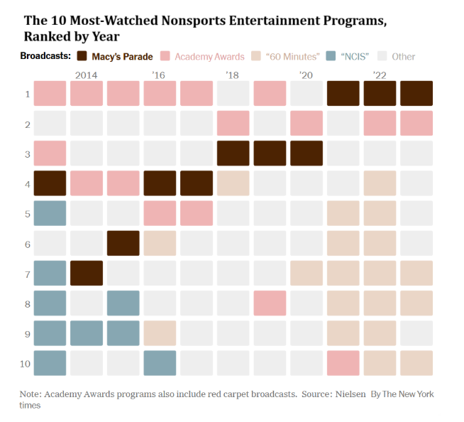
This graph visualises how the top 10 most watched non-sport entertainment programs have changed per year. The date ranges across the x-axis start with 2014 and from then on drop the 20 in the year, this inconsistency means the reader must assume ’16 and so on refer to 2016 etc. The dates are plotted every 2 years however there is data for every year and the current labels suggest the dates start from 2014 which isn’t the case.
The y-axis could be labelled to highlight the ranking e.g. ( where 1 Is the best and 10 is the worst).
The choice of colours could also be better as ’60 minutes’ and ‘other’ are harder to read on the legend. If the graph was printed in black and white it likely be challenging to differentiate between ‘Academy Awards’ and ‘NCIS’
The legend includes quotations for ’60 minutes and ‘NCIS’ but not the others. This is something that should be removed. Also, it could go into more detail by adding more elements rather than using other as it is unclear what was the 2nd most watched program was for 2013-2017 is for example.

